**LEBANESE AMERICAN UNIVERSITY**

**USAID – HIGHER EDUCATION SCHOLARSHIP PROGRAM**

**HES - Volunteering Program Verification Form**

This form is to be used to document volunteering hours. If a student volunteers for multiple organizations, a separate form must be used for each organization. **This form must be turned in by the 28th of each month, the latest.**

I certify that the scholar Ghida Bilal Abou Zaher completed a total of 8 hours of service at Life Sculptor.

The hours were completed hours as per the below:

Hours # 0 (date) _30/09 – 5/10_ (initials of supervisor) __A.K.___

Hours # 2 (date) _7/10 – 11/10_ (initials of supervisor) __A.K.___

Hours # 2 date) _14/10 – 18/10 (initials of supervisor) __A.K.___

Hours # 4 date) _21/10 -25/10 (initials of supervisor) __A.K.___

Brief description of the activities the scholar performed or participated in:

Ghida was assigned a monitor supervisor for the Will & Wellness Club under the supervision of Life Sculptor Managment Team. It is essential that she assigns volunteers for the workshops, sends workshop links, fills weekly reports regarding the attendance of the workshops, and gives an overview of the feedback concerning its flow and engagement.

Written feedback about the scholar’s performance:

Ghida has taken on a critical supervisory role within the Will and Wellness Club, demonstrating strong organizational and management skills. Her responsibilities in assigning volunteers, managing workshop logistics, and providing feedback reflect her ability to oversee projects effectively.

Please rate the overall performance of the scholar at your organization:

|  |  |  |  |
| --- | --- | --- | --- |
|  | Mastery (5) | Proficient (3) | Emerging (1) |
| **Problem solver** | X |  |  |
| **Engaged & Committed** | X |  |  |
| **Open-minded & multicultural** | X |  |  |

Signature

& stamp

__________________________

_

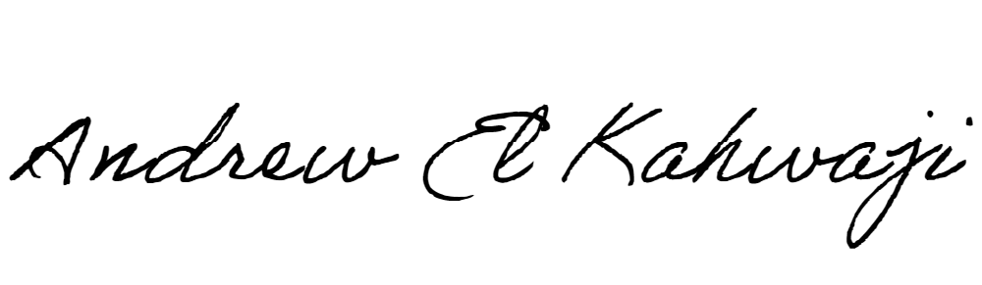

Printed Name _Andrew El Kahwaji_

Date __26/10/2024___

Email __andrew.lifesculptor.coo@gmail.com __

Phone __+961 71 914 378__

**LEBANESE AMERICAN UNIVERSITY**

**USAID – HIGHER EDUCATION SCHOLARSHIP PROGRAM**

